HIGH FREEQUENCY FINANCE CORSEWORK 2 (intrinsic time trading strategy)

Parsa Raziei 26/03/2025

Continuation to Part 1
This is a continuation to the first part which is in the Jupyter Notebook file. This segment is to explore the excel files created by the program and analyse each of their content.
Output-refined.xlsx
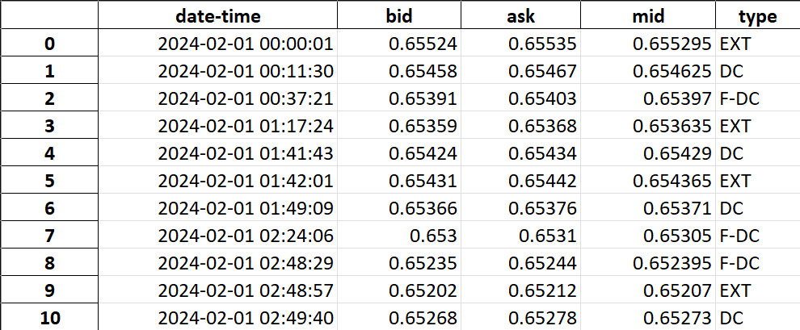
This file stores all the local extremes, the directional changes and the further directional changes for the specified period. The structure of the table is the following:
These are the points the data which form the market time. The type is representative of the points classification, either extreme directional change or further directional change. The exact time of each of these intrinsic data points alongside their bid, ask and mid-price is stored in the excel file.
Positions.xlsx
The storing of opening and closing positions is done via this file. The opening of each position must be done if the current timestep is a directional change or a further directional change.
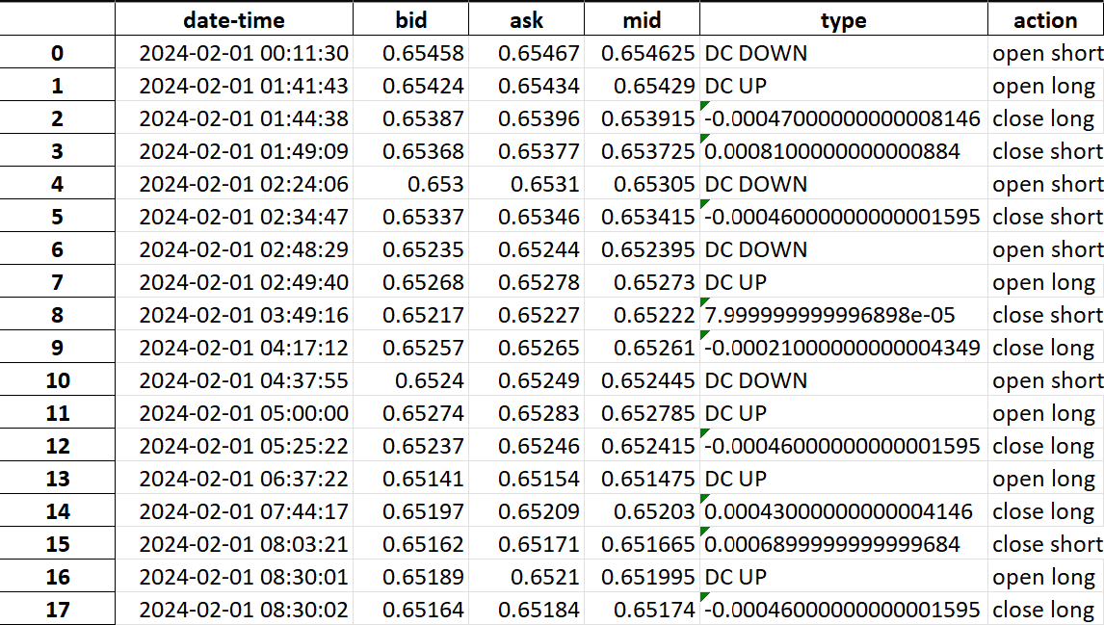
The time, bid, ask, and mid prices correspond to the specific timesteps market quotes. The type entails what type of point we are currently on if we are opening a position. In other words, it assigns an opening, a long or short one depending on the nature of the directional change. If the point is where the price has hit the Take Profit or Stop Loss, then the position is closed, and the type of the point for these entries is simply the profit if positive and the loss if negative for this specific position.

Intrinsic time graphs
The graph on the left showcases the local extremes of the data using red crosses, while the blue dots are illustrative of the directional changes or further directional changes. On the left graph the further directional changes have been filtered out and the blue lines only to show the directional changes. This is a graphical representation of the tick data for a short interval, it displays the prominent points in the graph and which of the market movements are significant and essential to pay attention to and eliminates the noise to a certain degree.

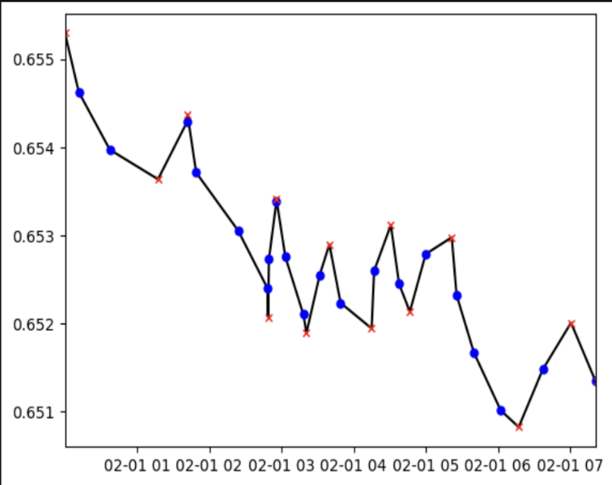
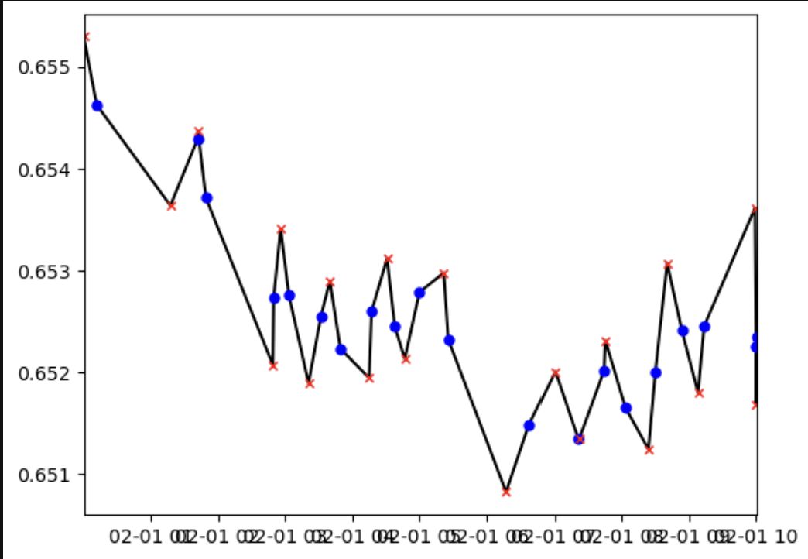

Back testing
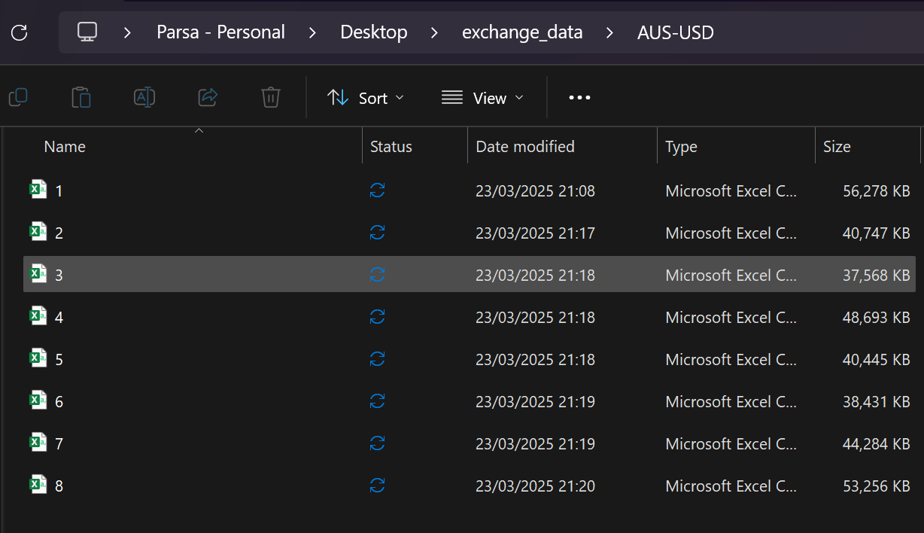
- The first step in order to back test the trading strategy is to obtain and store some historical tick data. 8 different data sets, each corresponding to one of the first 8 months of 2024 for the AUS/USD currency pair are put in the following folder, with the highlighted explorer address. (Each file number is indicative of what data of that month in 2024)
- Lastly, we transfer all of the code within the Jupyter notebook to VSCode. This allows us to run a gargantuan for-loop over all the code. This way, when the file is run, it applies the strategy and backtests it on every single month individually and stores each single month's performance. This allows us to run a bunch of backtests simultaneously.

Creating a DataFrame to store the results of each back test that was executed. Backrests performance is evaluated by the amount of profit or loss it has made and the ratio of successful positions to all of the positions that were opened within the given interval. Each entry also contains the details on the month it corresponds to and number of positions which led to profit and loss.
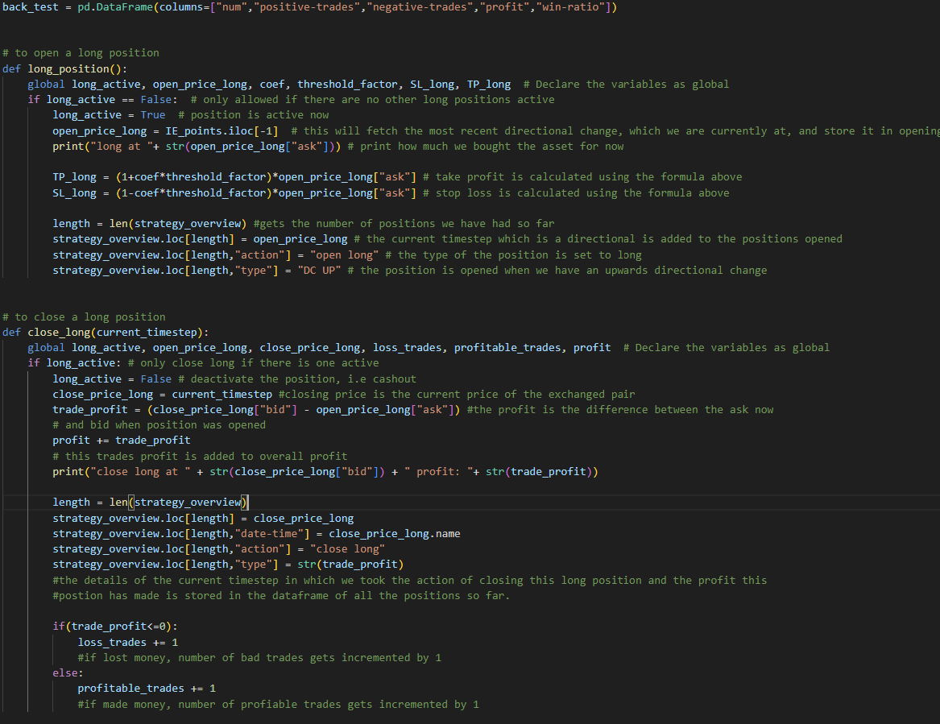
- In order to avoid redefining functions and variables, certain variables and methods for opening and closing positions in the market are defined outside the loop for all the months we want to back test. This is basically the same blocks of the Jupyter notebook file but reordered to avoid needless computation.
Note that the screenshot only captures two of the functions that we have defined outside back testing loop. This due to the length of the code only two functions are being presented for explanatory purposes, all the functions are now defined outside the loop.
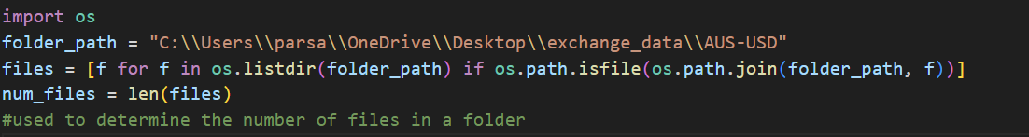
- Defining the loop that is used for back testing on the files we have saved to the AUS-USD folder. The first step is to figure out how many files we have in the specified folder this could be done by using the OS library and the following piece of code.

Now that the number of csv files that we want to back test on is stored in the num_files, we can start defining the loop, what this loop does is that every time we want to utilize our trading strategy on one of the files it increments a variable in the file path so that it would point at the next CSV file in the folder. This way we back test through all files named 1 to num_files (the final file in folder).

- The next step is to carry out the trading strategy on data for each specific month, the rest of the code in the jupyter notebook file which was about the detection of the local extremes and directional changes and when to open positions goes in this loop. Whenever the month variable is incremented, and the loop is re-entered. After resetting all the related variables such as the profit and the successful and failed position to zero, the program starts finding the directional changes and opening and closing positions with respect to the directional changes in the price movement, Stop Losses, and Take Profits.
The following is a screenshot that partially shows the content of the loop.
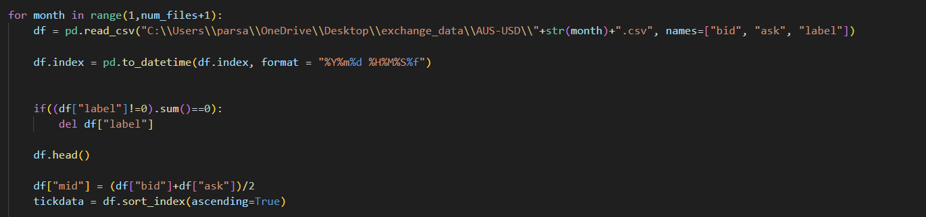

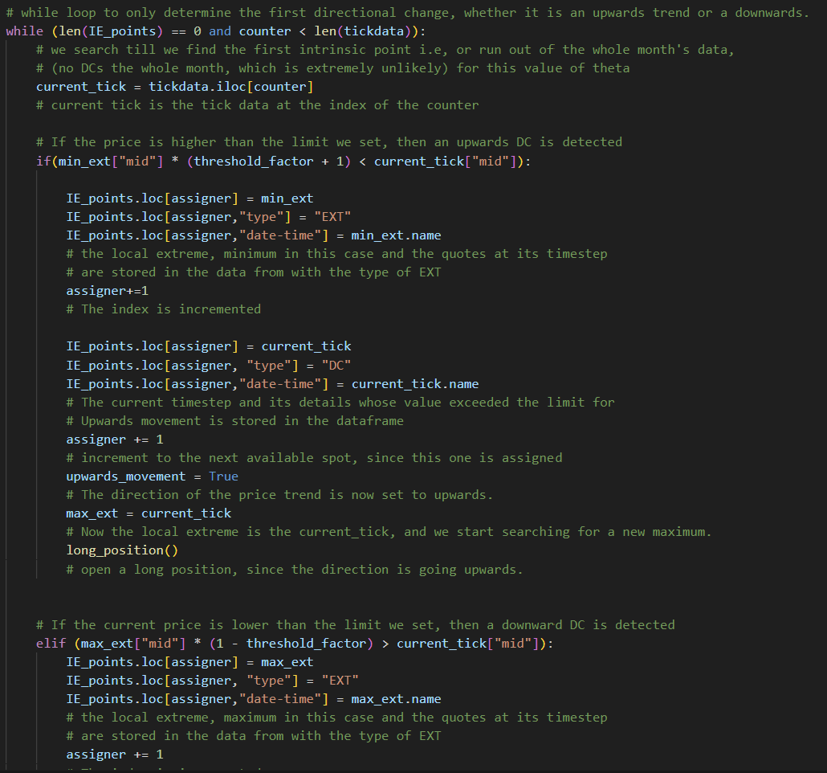
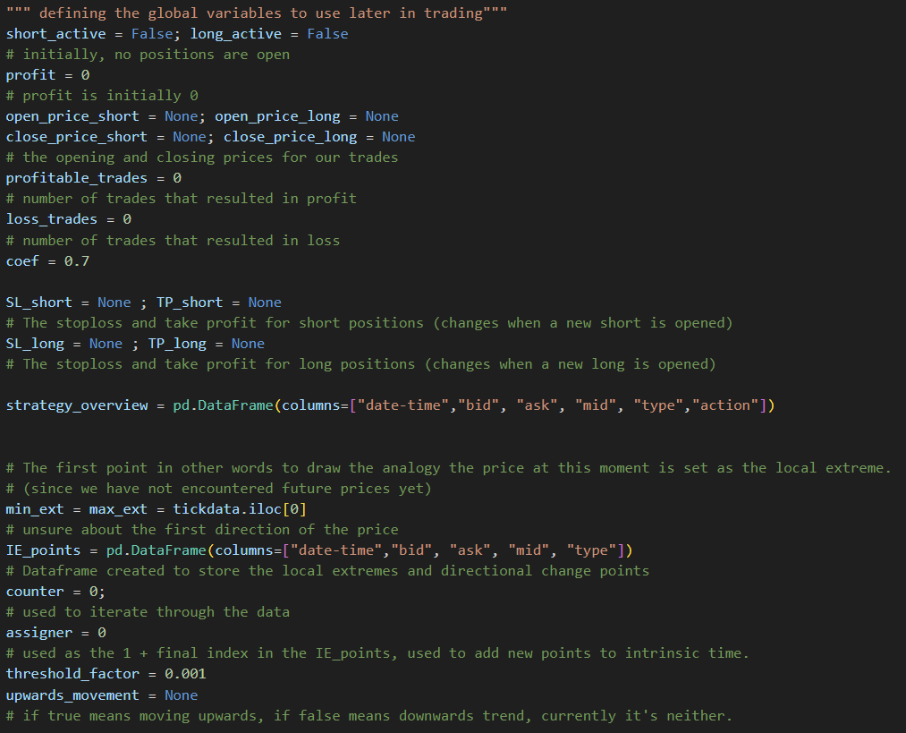
- For each of the iterations of the loop when we have traded using our strategy for that period the performance is assessed and stored in back tests data frame. This could help us determine how well the strategy has performed within that specific period.

- Once the execution of the entire for loop has ended the content of the back test data frame is extracted to an excel file for further analysis.
This is how the excel file is structured, for each month, it tells you how well the strategy has performed by showing the number of profitable trades and the ones led to a loss, the net profit within that month and the win loss ratio of the strategy.
It is worth noting that the profit or loss is proportional to the initial money invested. So if we have the profit as -0.04 this means that this strategy has resulted in a 4% loss of our initial capital.

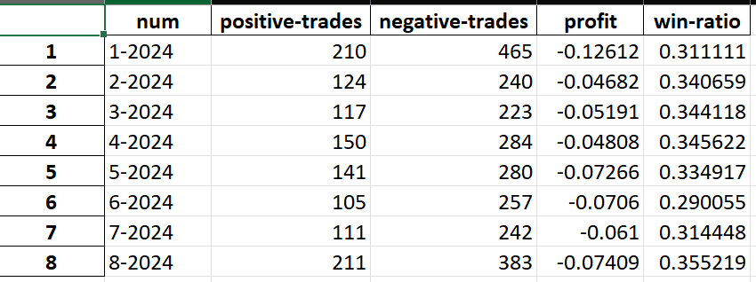
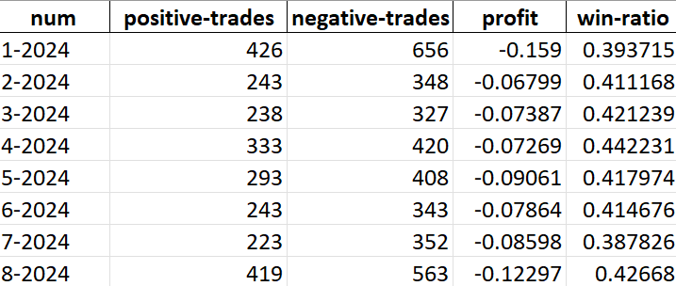
Analysis and Comparisons
Left table the performance of the Dynamic SL and TP, Right table the performance of the fixed take profit and loss.
The first trading strategy of entering only short and long positions with a fixed take profit (TP) and stop loss (SL) has a smaller average profit. In fact, because the net profit is negative, it means the strategy has more losses. However, the win percentage of the strategy is higher than that of the strategy that dynamically sets TP and SL.
That is, fixed TP and SL strategy has a higher number of profitable trades than the dynamic TP and SL strategy. However, the profit from these trades is relatively low. On the contrary, although the dynamic TP and SL strategy experiences fewer winning trades and more losing trades, losses are larger compared to the fixed TP and SL strategy.
The loss or the profit always varies from one month to the next but it a pattern can be seen that in the months that one of the two trading strategies has a high level of loss, the other one also performs similarly. For instance, if using trading strategy 1 in January of 2024 results in a huge loss, the second trading strategy would also have a lousy performance in this month relative to its typical performance.
Moreover, due to how simplistic both strategies are it was given that neither of them would be making significant profit. Companies and investment firms use over several techniques and tools to be able to make consistent profit within these market and without a question those ones would outperform our strategies by high margin.

Limitations and possible improvements
There are some limitations in the current strategy that could be addressed for better results:
- Single Position Limitation: The strategy only allows for one long and one short position at a time. Lifting this restriction might lead to better profits, as it would enable multiple positions of the same type to be open simultaneously, offering more trading opportunities.
- Fixed Position Size: Each position is currently opened with a fixed size of one unit. Allowing the strategy to determine the position size based on various factors and market conditions could improve profitability and risk management.
- Varying Theta (ATV): The threshold factor, θ, is currently constant. Introducing an Adaptive Threshold Volatility (ATV) would allow θ to adjust based on the recent volatility and variability of the market data, enabling the strategy to respond more dynamically to changing market conditions.
- Volume Weighted Extremes: The detection of local extremes, as of now, solely depends on the price. This could be improved by also checking what volume has been traded at that extreme. A larger volume at an extreme could be indicative of an important point in comparison to an extreme with a lower traded volume. You can use weighted volume extremes to confirm directional changes (DC) in your trading strategy. When a price moves significantly (up or down), you check if the volume at that point exceeds a predefined threshold. This helps to ensure that the price move is supported by significant market activity.
- Incorporating AI: A Reinforcement learning agent may be taught to adaptively set stop-loss (SL) and take-profit (TP) dynamically based on market situation, e.g., to raise the SL in times of high volatility in order to prevent early stops. A machine learning model may be employed to generate buy/sell signals from technical indicators, e.g., moving averages or RSI, to forecast direction of price. The models may be blended for optimal trade execution by adaptively setting SL/TP and generating signals based on historical price information and current market conditions.

